Nalongsone Danddank Student ID : 14958950 StarID: jf3893pd

Email: [nalongsone.danddank@my.metrostate.edu](mailto:nalongsone.danddank@my.metrostate.edu)\

**ICS 432 - 01 — Distributed and Cloud Computing Fall 2021**

**Lab #1 :** Getting Started with AWS and GCP

Part 1: Getting Started with AWS.

Exercise 1: Getting started with AWS Management Console – AWS Educate.

**Lab report screen-shot #1:**

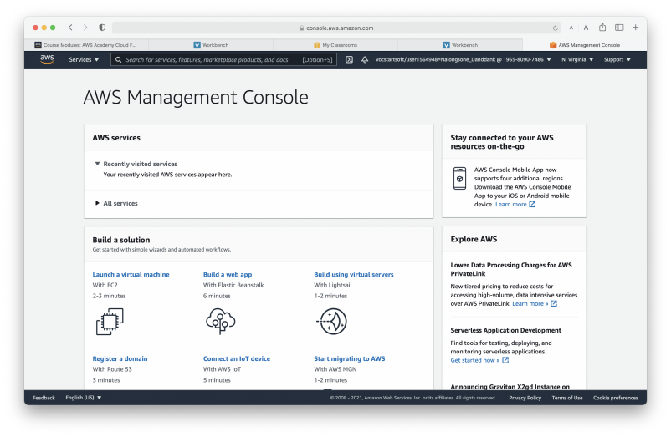

**Lab report screen-shot #2:**

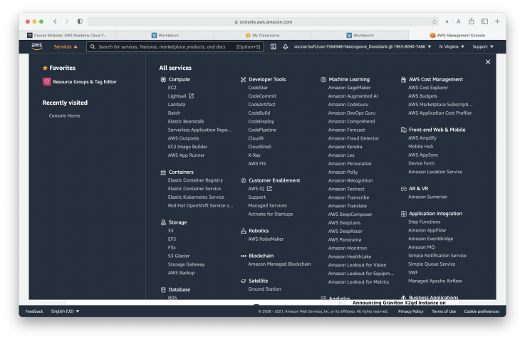

**Lab report screen-shot #3:**

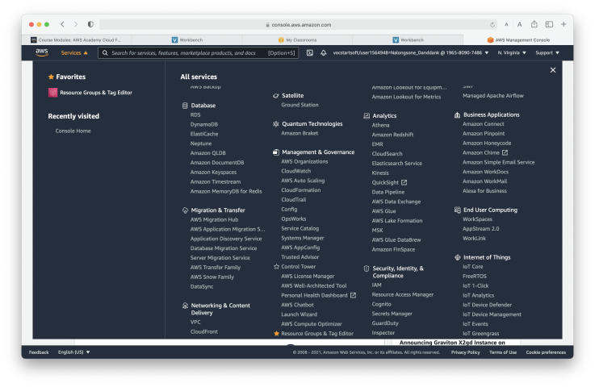

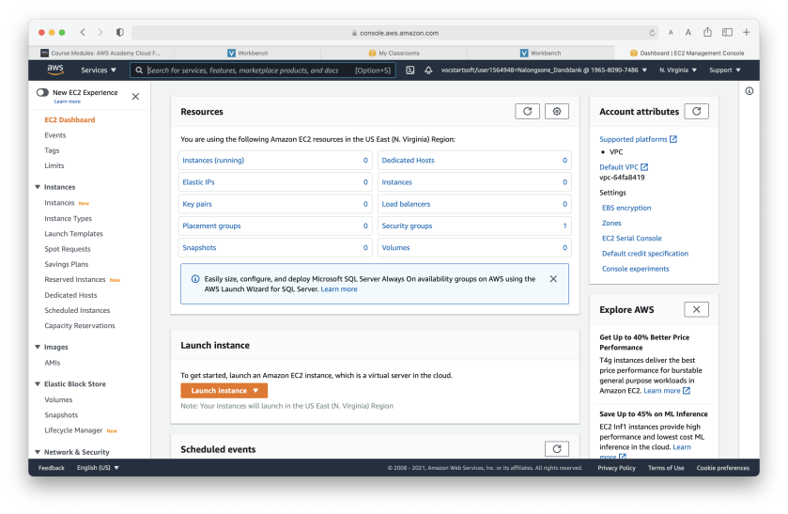**Lab report screen-shot #4:**

**Lab report screen-shot #5:**

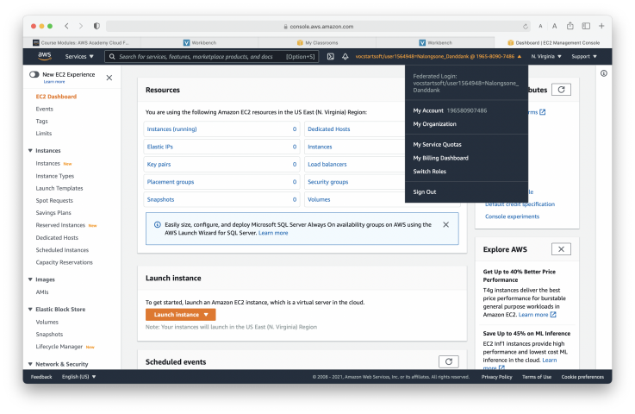Exercise 2: Educate.Complete AWS Academy Course Lab 1

**Lab report screen-shot #6:**

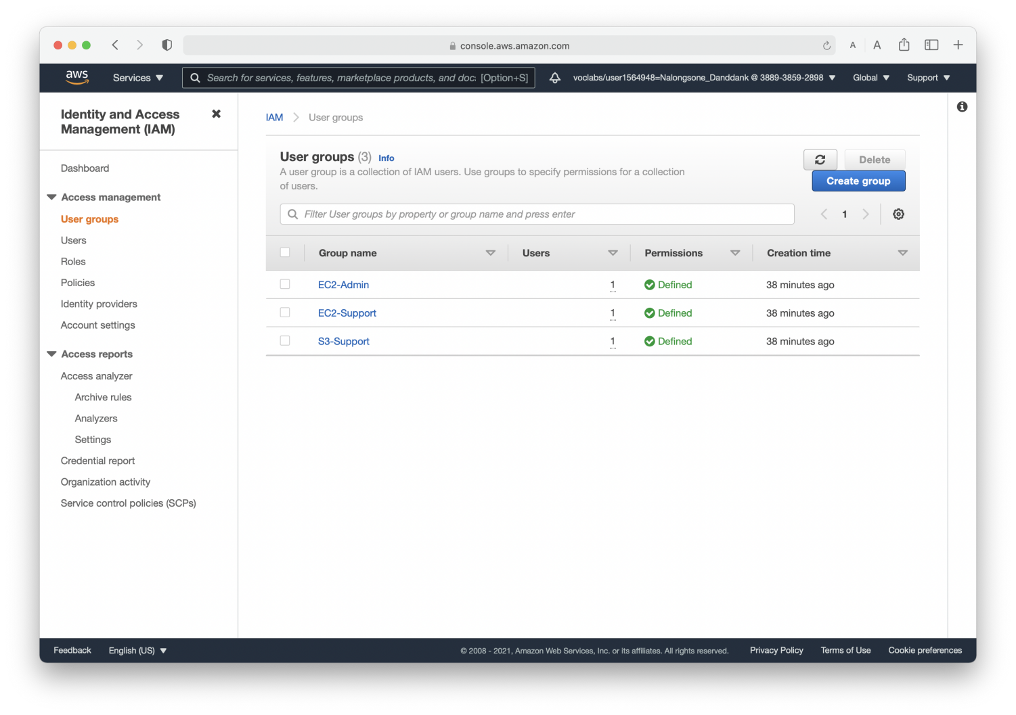

**Lab report screen-shot #7:**

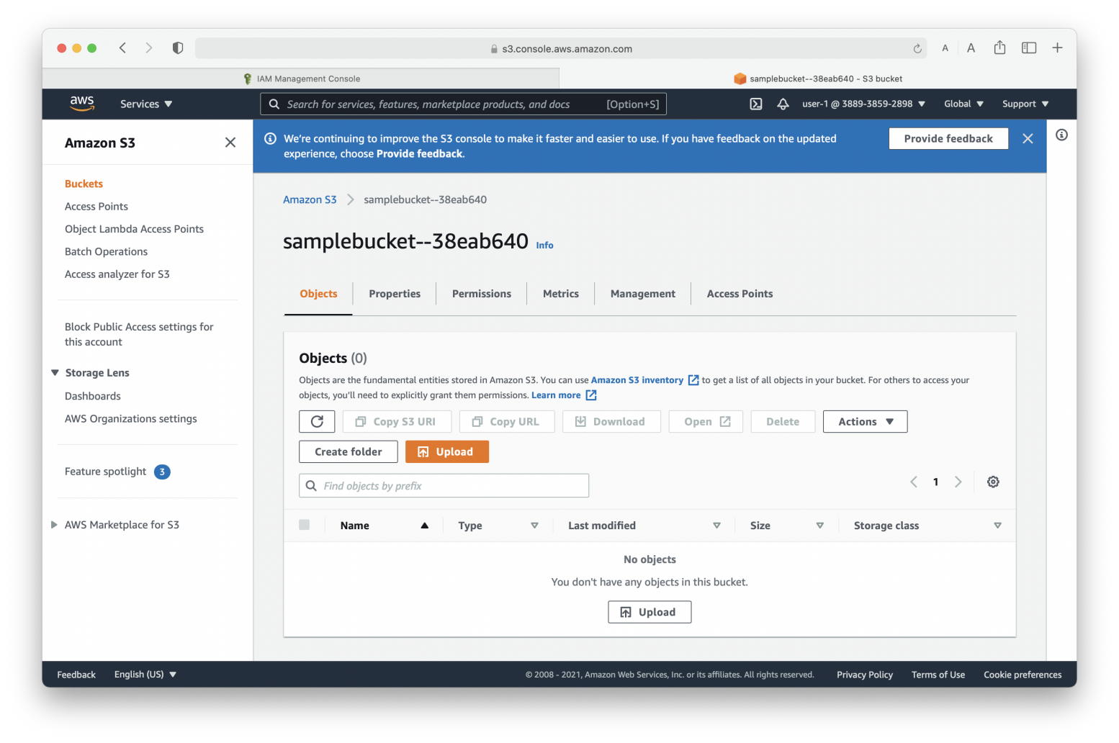

**Lab report screen-shot #8:**

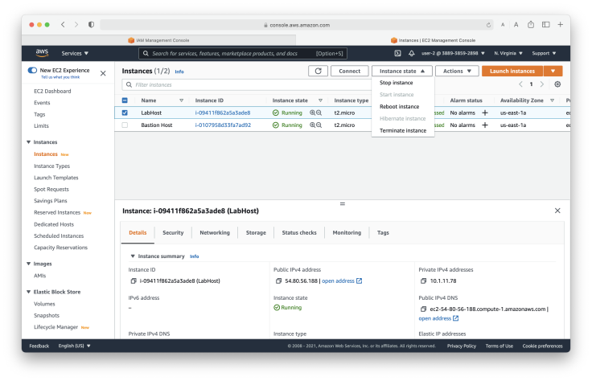

**Lab report screen-shot #9:**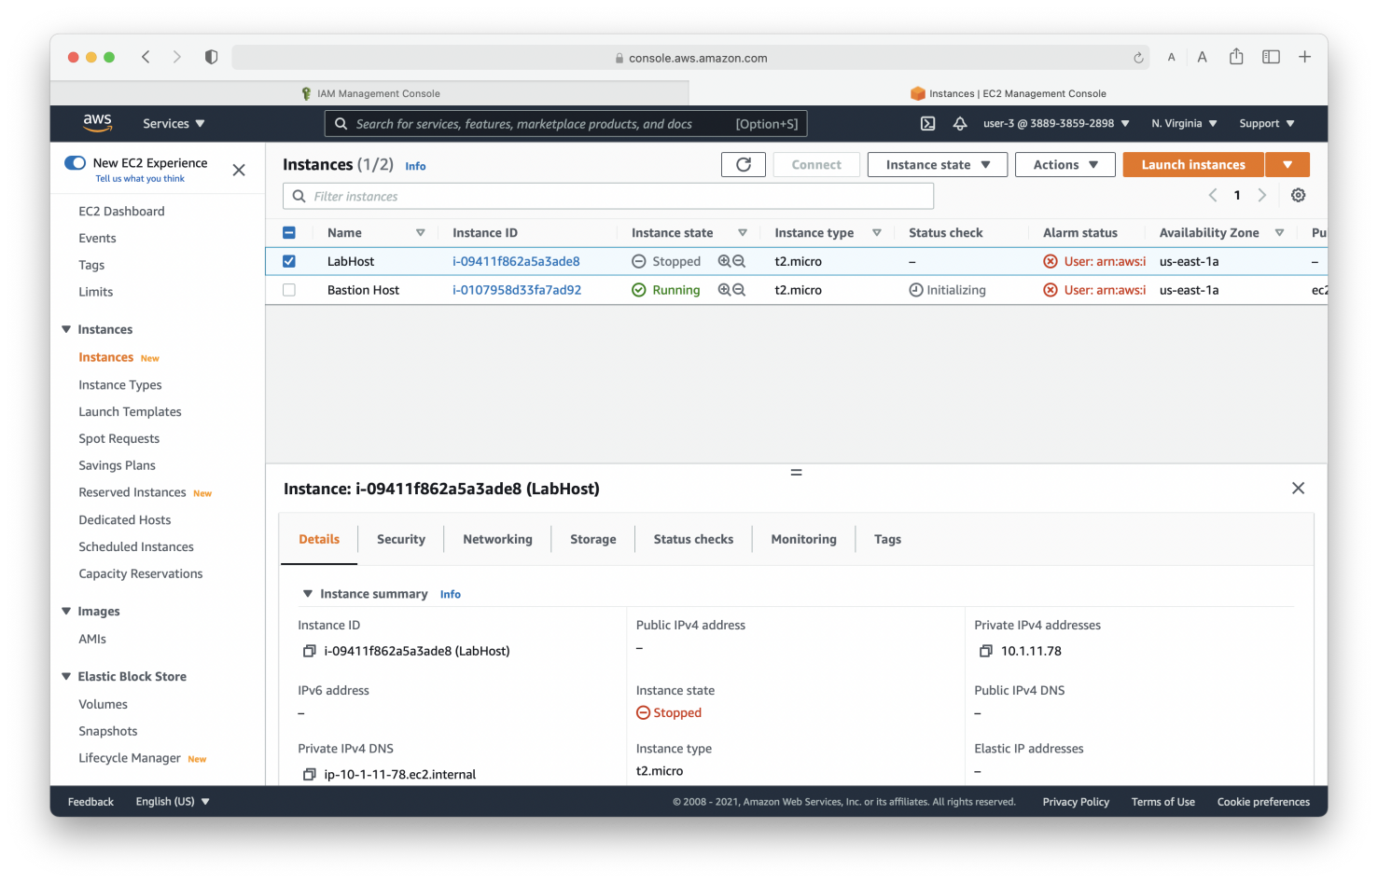

Part 2: Getting Started with GCP.

Exercise 3: Qwiklab 1: A tour of Qwiklabs and Google Cloud.

**Lab report screen-shot #10:**

Project ID:  qwiklabs-gcp-00-8dbaab89463d

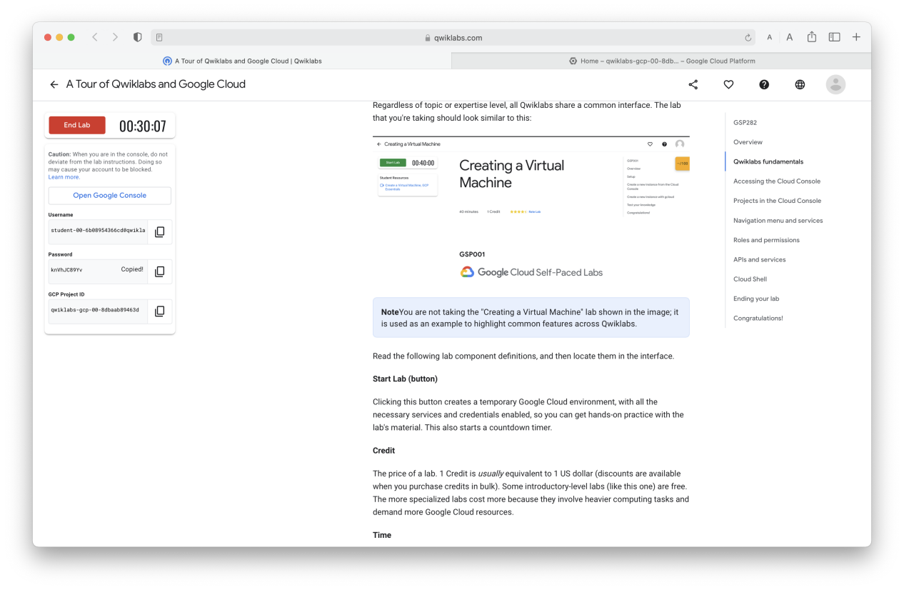

**Lab report screen-shot #11:**

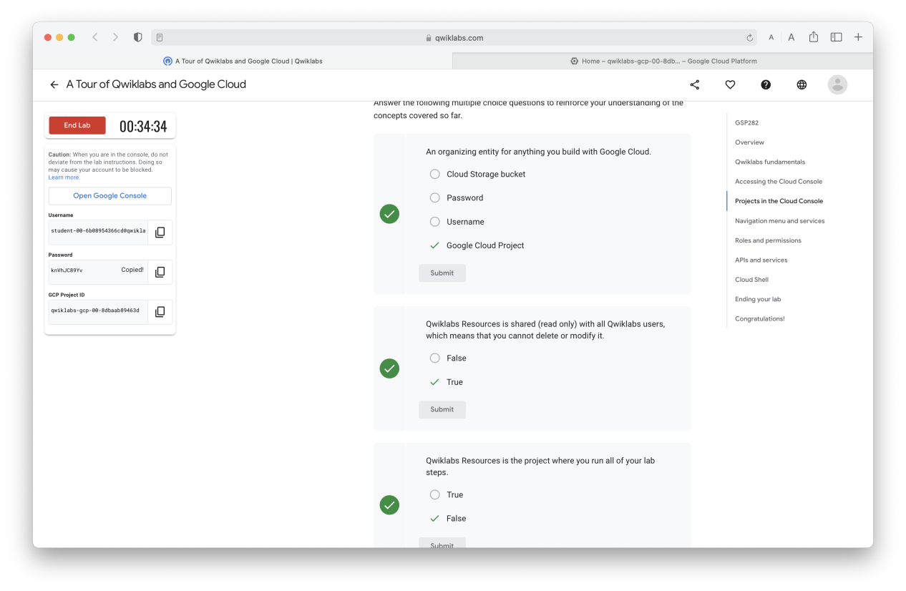

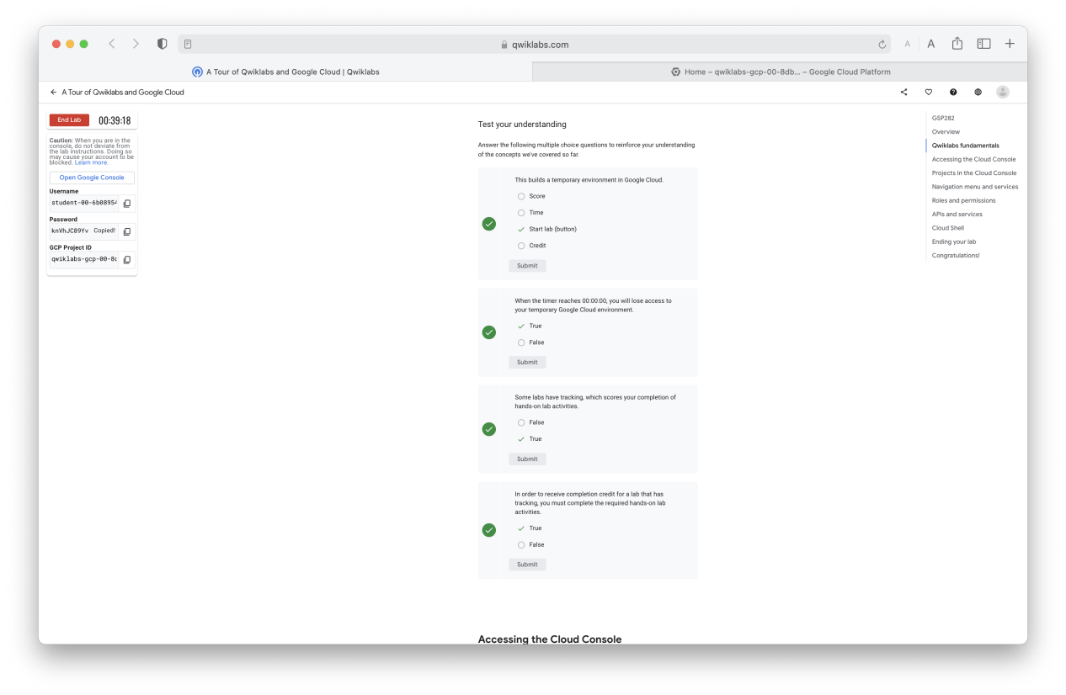

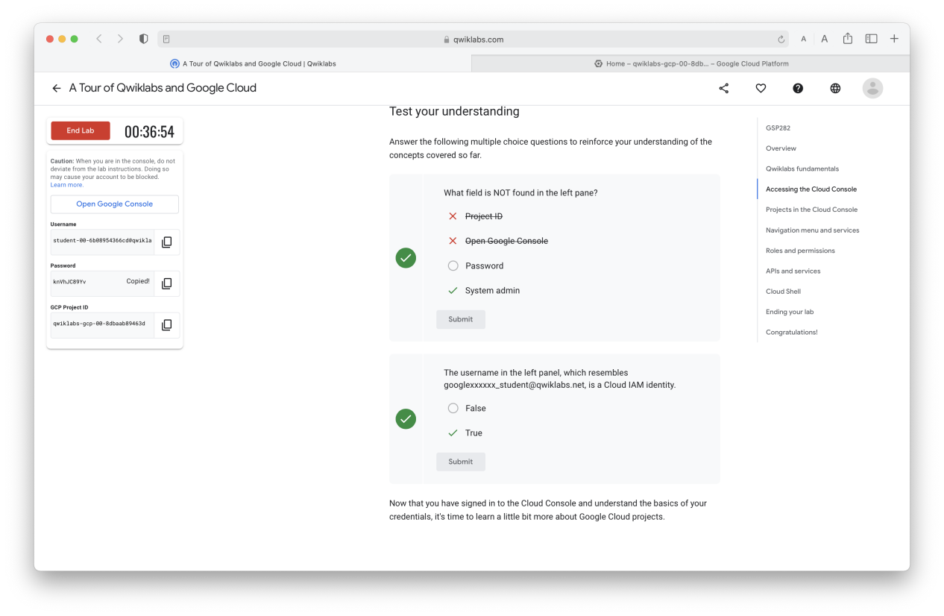

**Lab report screen-shot #12:**

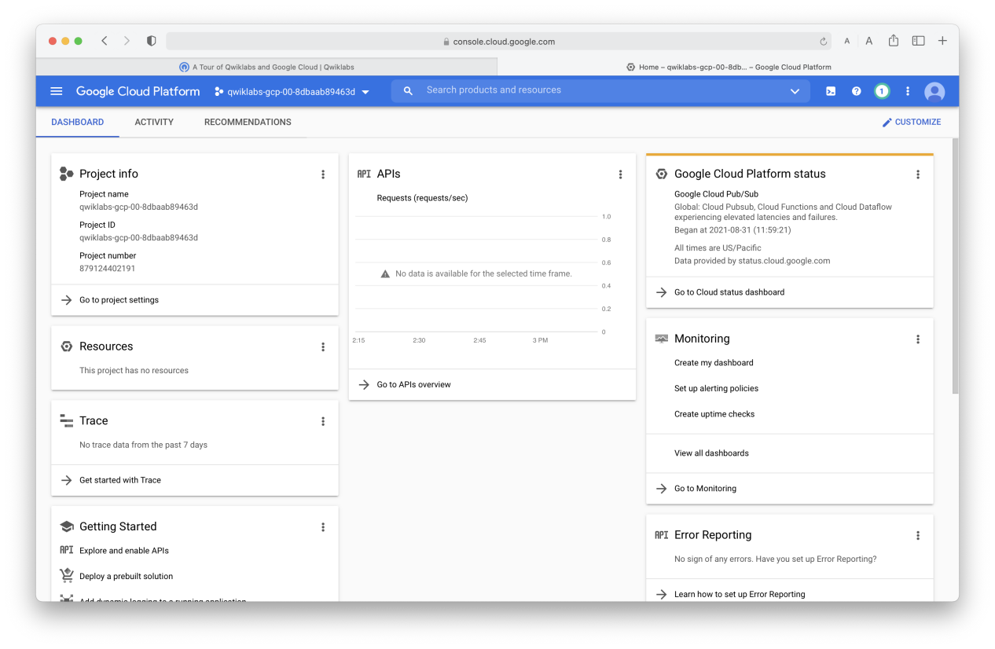

**Lab report screen-shot #13:**

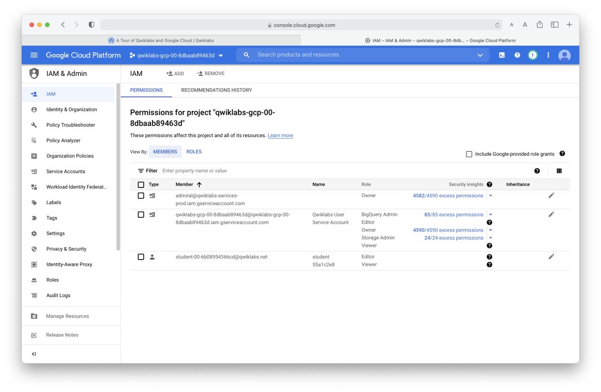

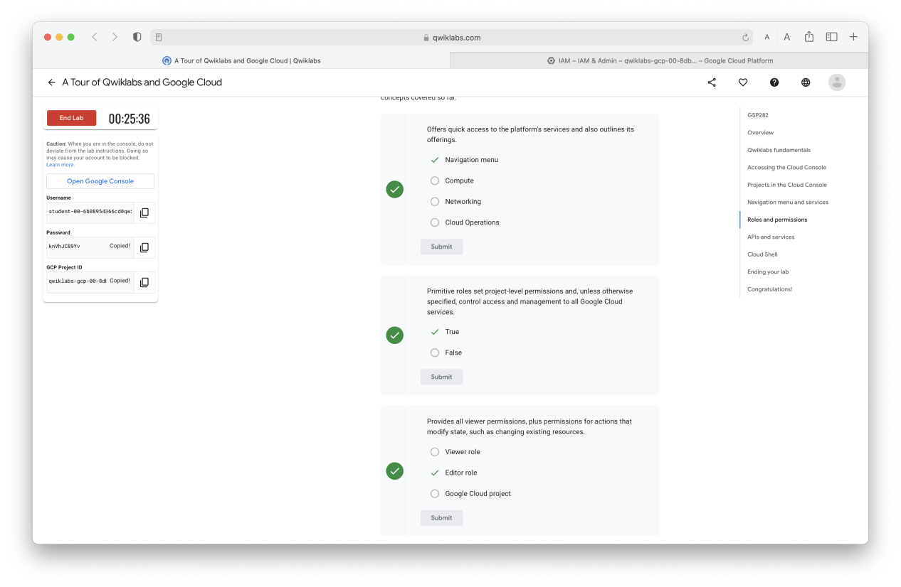

**Lab report screen-shot #14:**

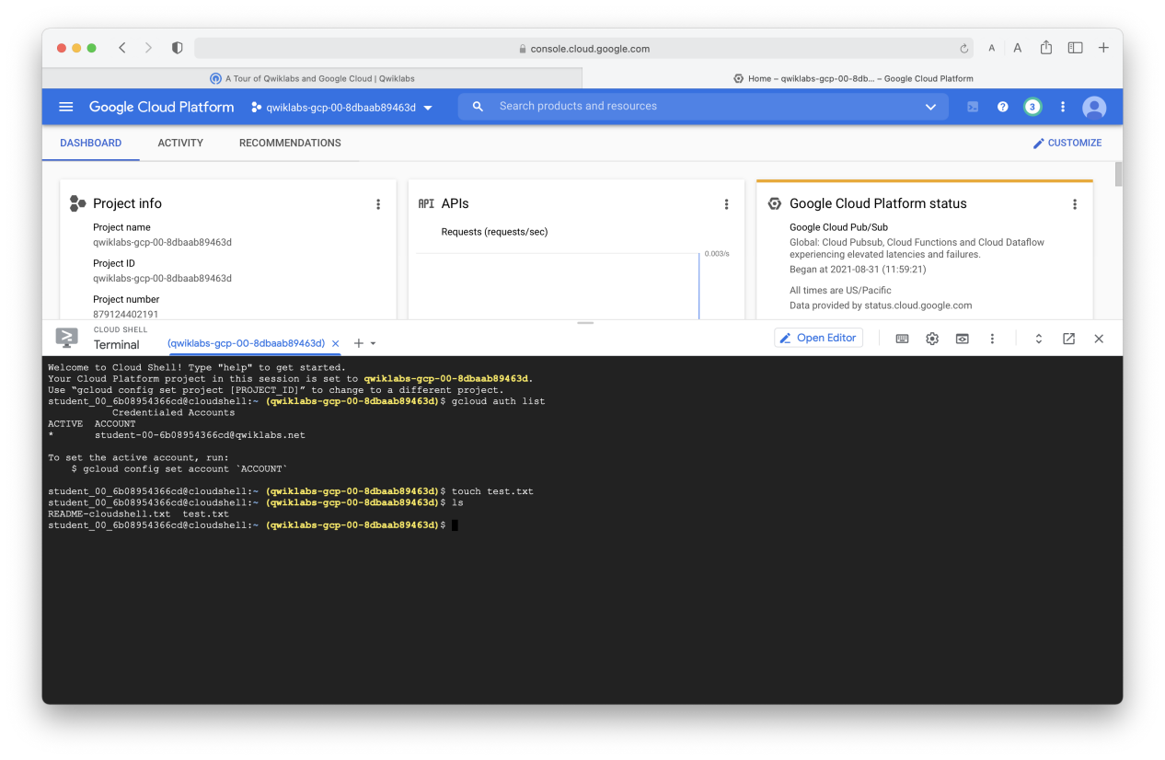

**Lab report screen-shot #15:**

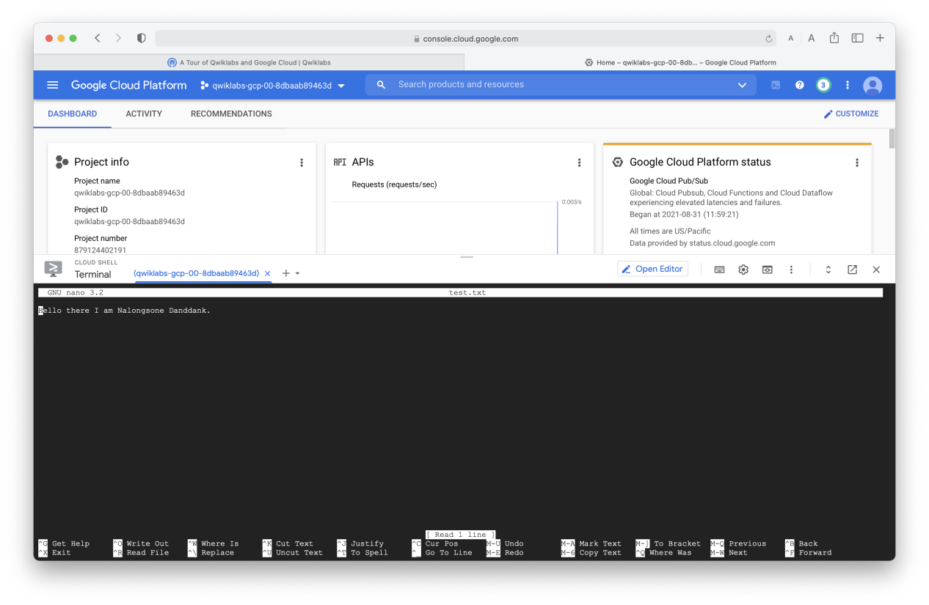

**Lab report screen-shot #16:**

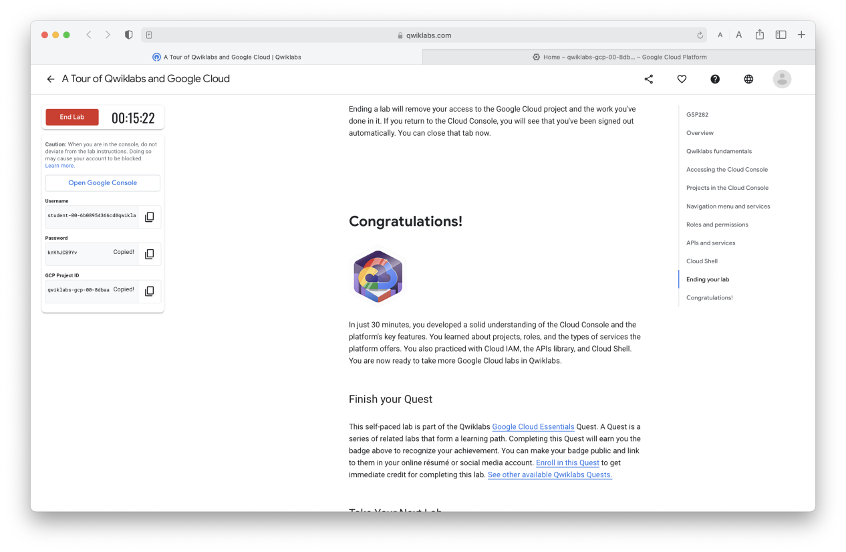

**Exercise 4: Qwiklab Lab 2: Cloud IAM: Qwik Start**

**Lab report screen-shot #17:**

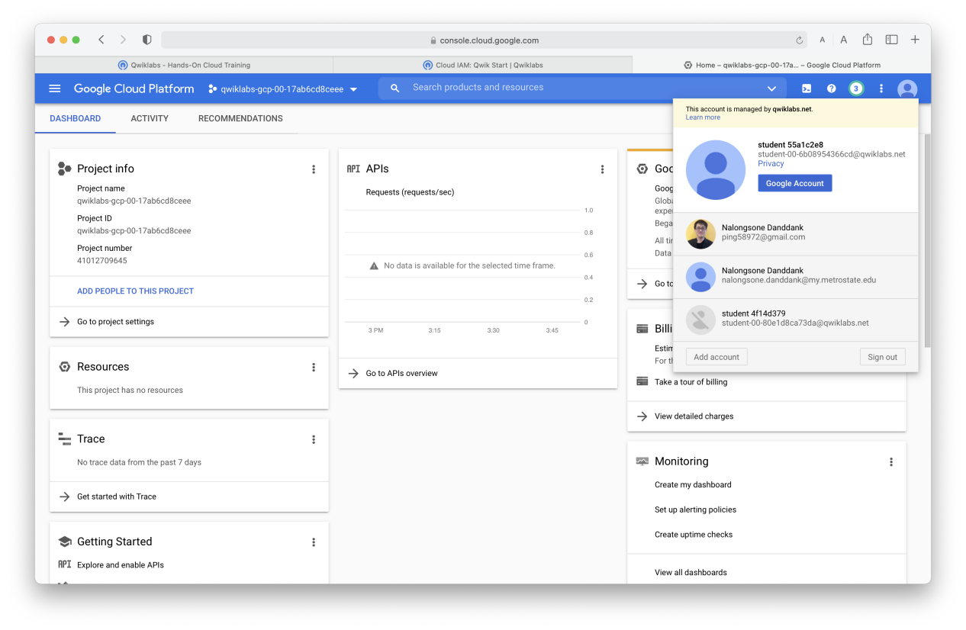

**Lab report screen-shot #18:**

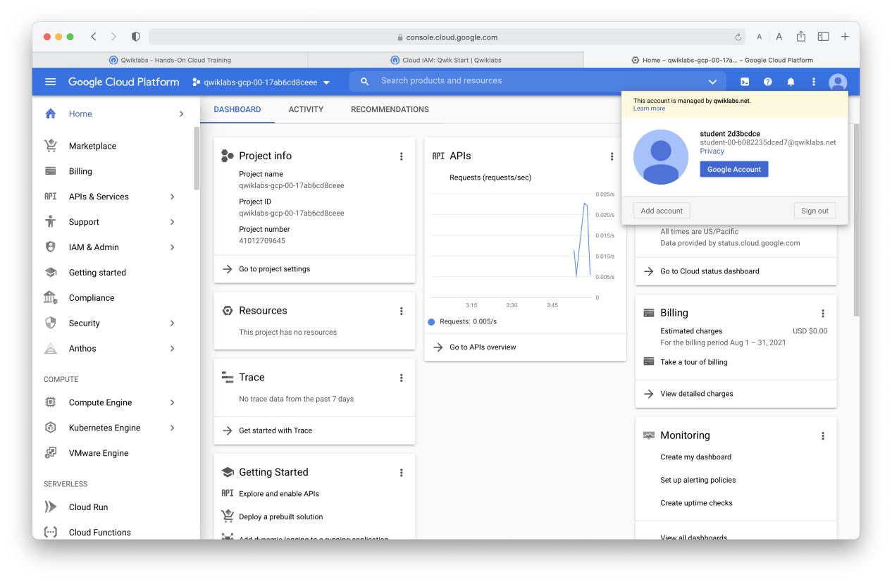

**Lab report screen-shot #19:**

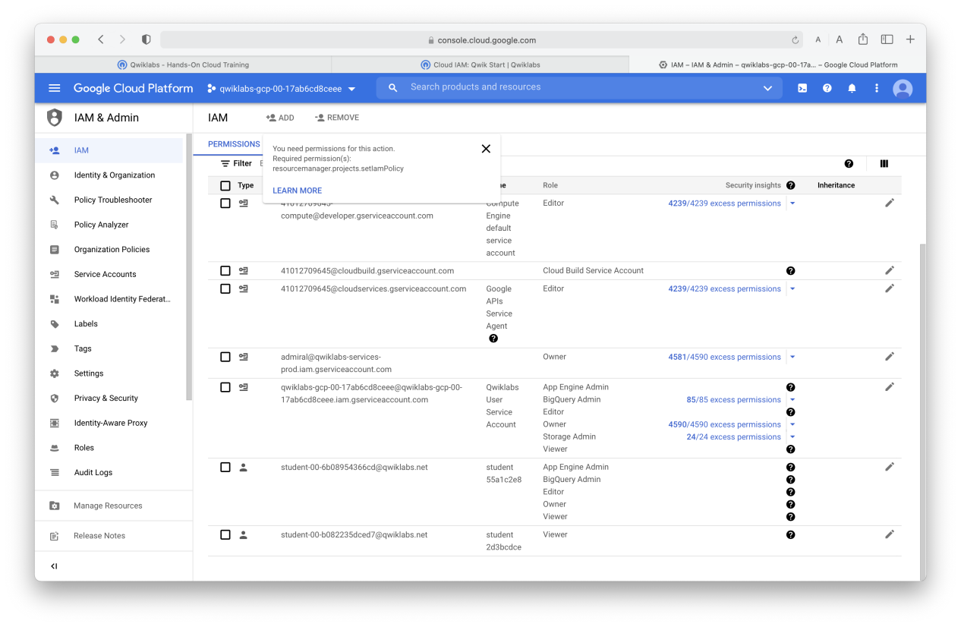

**Lab report screen-shot #20:**

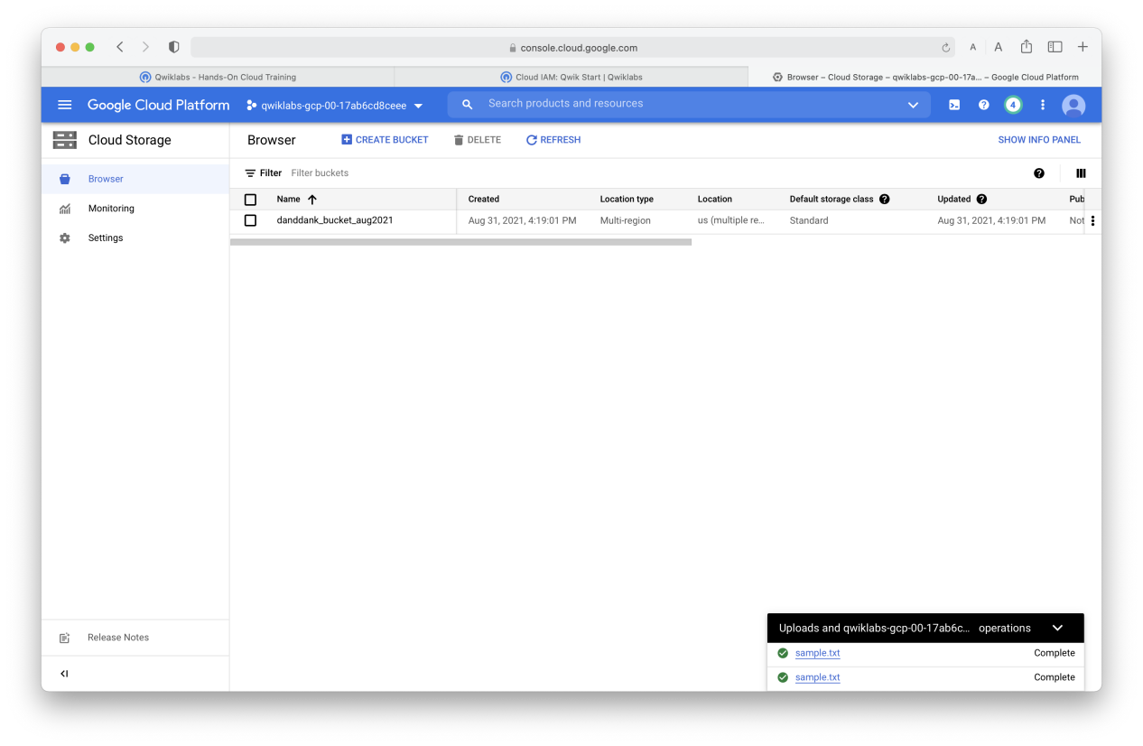

**Lab report screen-shot #21:**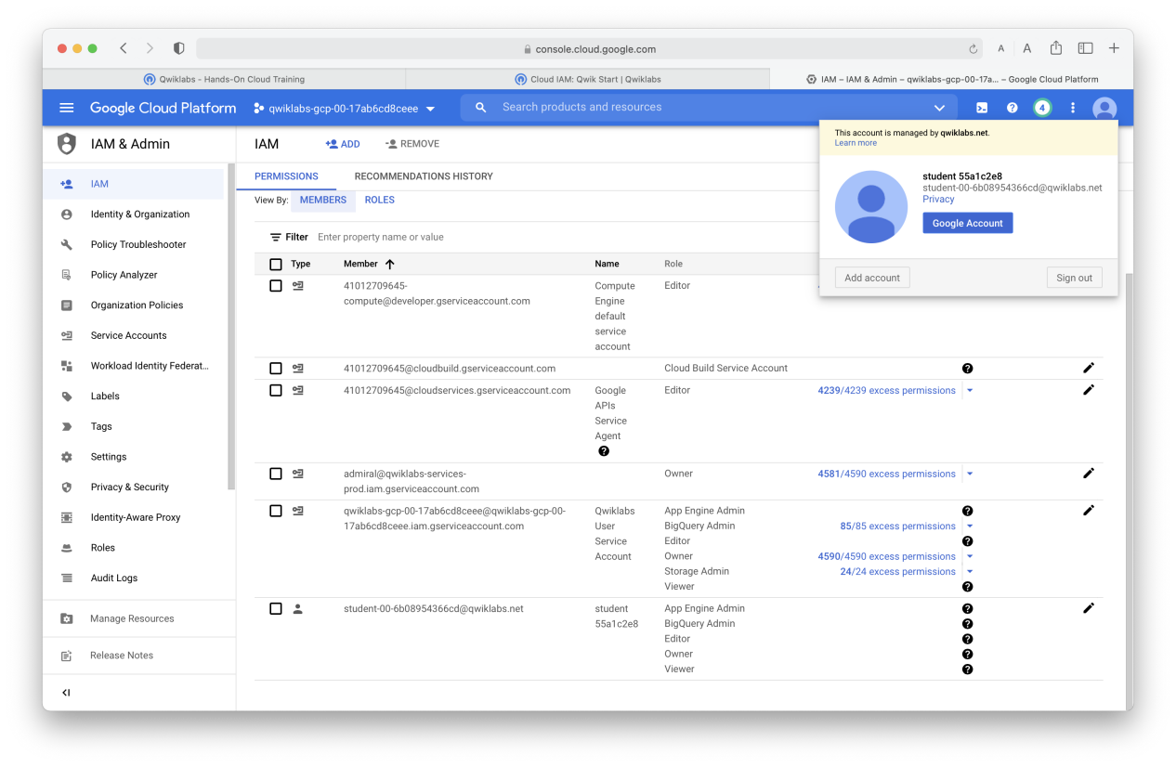

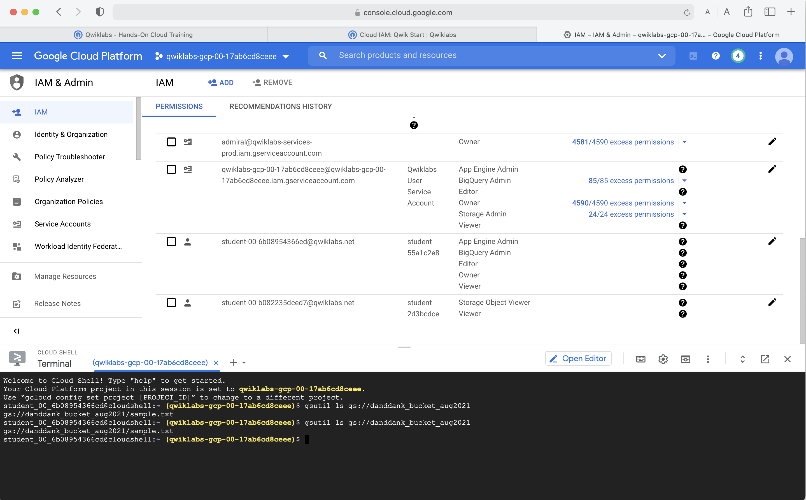

**Lab report screen-shot #22:**

